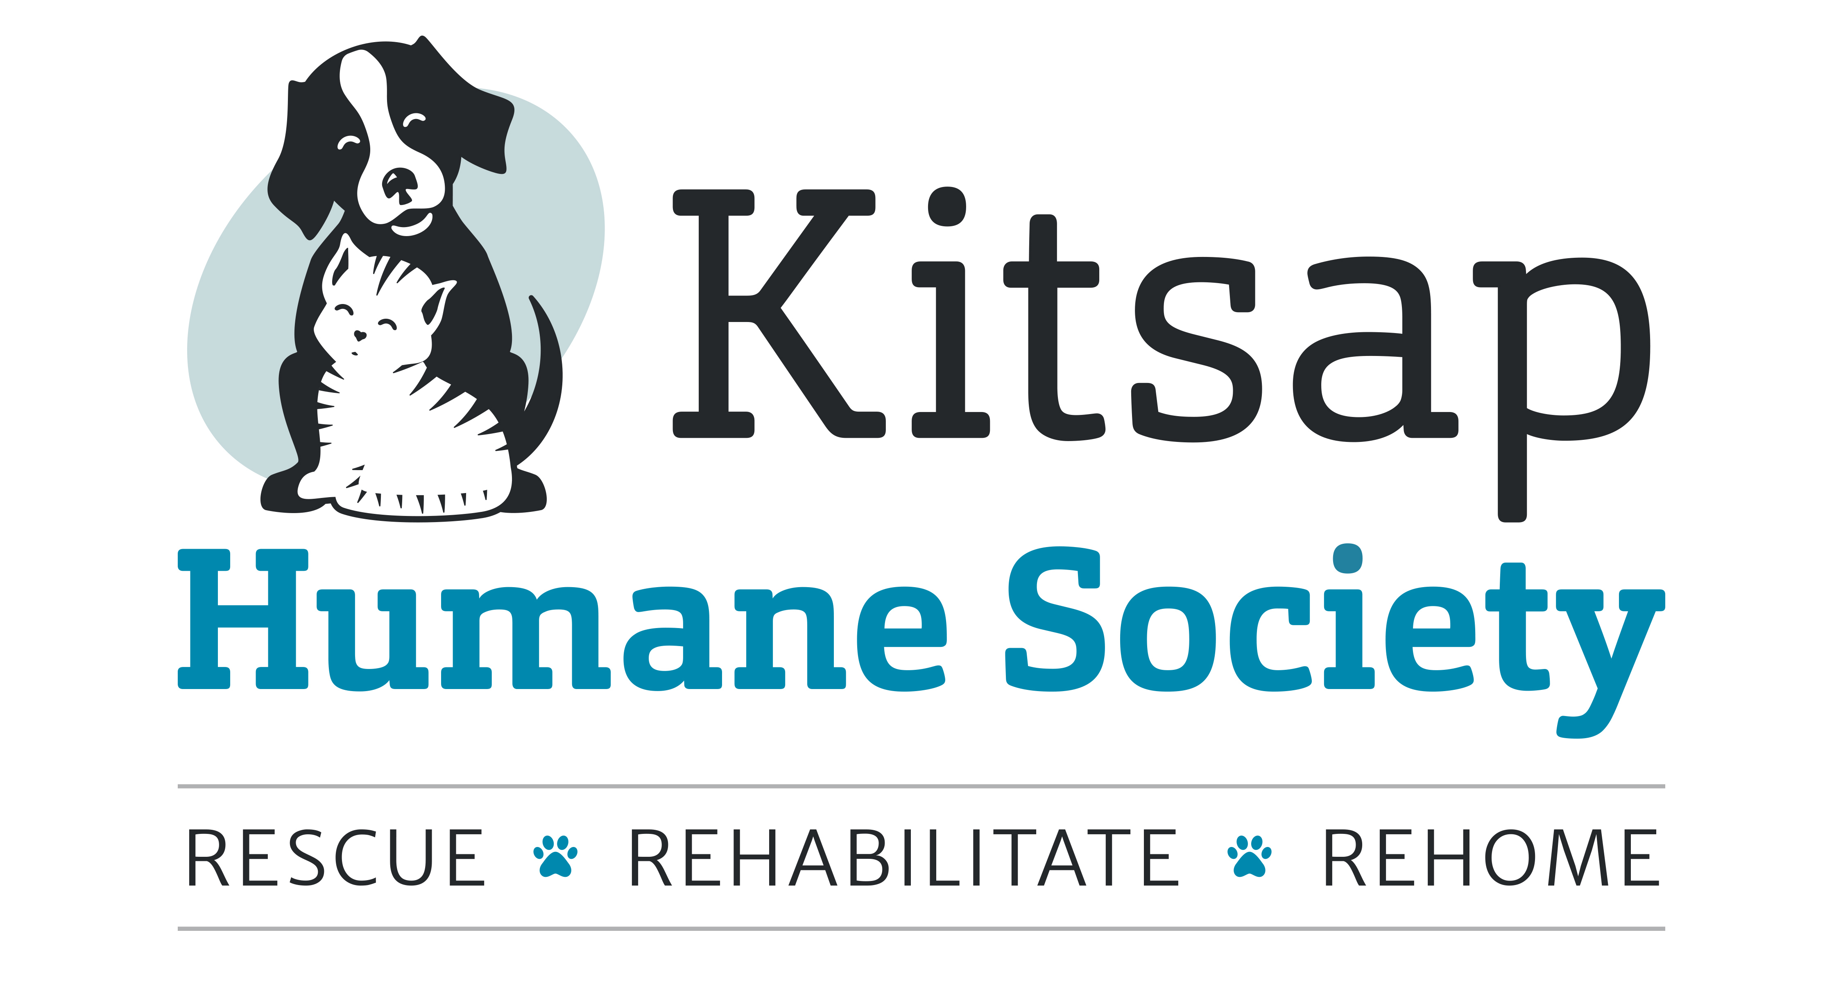

11th Annual Kitsap Wine Festival
Vendor Application

Space is limited, so please reserve your spot today! Basic tables and linens are provided. Please bring signage, chairs and any other equipment needed. Electricity is limited but may be available upon request. Vendors serving food must complete Health Permits and provide a copy to KHS.

Copies of insurance and health permits must be sent to KHS:
Attn: Rachel Wilson
Kitsap Humane Society
9167 Dickey Rd NW
Silverdale, WA 98383
rwilson@kitsap-humane.org
360-692-6977 ext. 1251

Funds generated through this event are dedicated to helping save the lives of animals at KHS. We reserve the right to deny participation of any organization that doesn’t align with Kitsap Humane Society’s mission. Please note that pets are not allowed at this event due to health code restrictions.

Business Name
Contact Name
UBI Number
Phone Number and Email
Website
Address
City, State, Zip
Type of vendor | ☐ Featured Winery ☐ Featured Restaurant  ☐ Other _________________________________
Will you bring wine  available for sale in our wine store?  Would you like to waive the $150 stipend in order have the most impact for our shelter pets? | ☐ Yes* ☐ No  *Vendor will be reimbursed for wholesale cost of all wine sold in the wine store.  ☐ Yes* ☐ No  *Vendor will receive a gift in-kind donation credit for wine served at the event.
By signing below, I agree that the information above is accurate to the best of my knowledge. I have read and agree to the Vendor Information Sheet also attached.

Signature:______________________________________________________________________________

Date: ____________________
Please return completed application by May 15, 2019 to be considered. Thank you!

